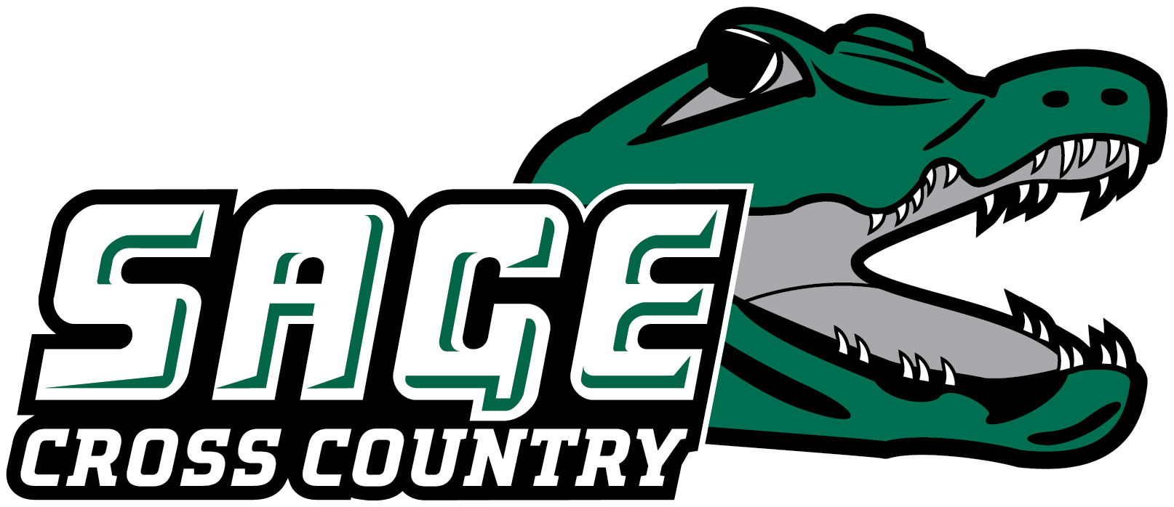
2024 RUSSELL SAGE COLLEGE CROSS COUNTRY ROSTER

Men
Name Yr. Hometown/High School
Robert Cusato Jr. Schenectady, NY/Guilderland
Jacob Haynes Sr. Cambridge, NY/Cambridge Central
Kyle Hess Fr. Arlington, VT/Arlington
Isaac Langer Sr. Hudson, NY/Taconic Hills
Chris Pellegrini Jr. Loudonville, NY/Colonie Central

Women
Name Yr. Hometown/High School
Alexis Hope Arango
Stephanie Beyer Fr. Lowville, NY/Lowville Academy
Merideth Diegel Sr. Albany, NY/Colonie
Charisma Losee Jr. Troy, NY/Lansingburgh
Head Coach: Regan Grube (Third Season, Bemidji State '19)
Assistant Coach: Sevi Travis
August 29, 2024

Office of Athletic Communications 140 New Scotland Avenue • Albany, NY 12208
www.sagegators.com

